**What Are SOLID Principles?**

The SOLID principles are a set of design principles introduced by **Robert C. Martin** (Uncle Bob) to make software design more maintainable, scalable, and robust. They serve as guidelines for object-oriented programming and aim to create a system that is easy to refactor and extend over time.

**SOLID** stands for:

1. **S**: Single Responsibility Principle (SRP)
2. **O**: Open/Closed Principle (OCP)
3. **L**: Liskov Substitution Principle (LSP)
4. **I**: Interface Segregation Principle (ISP)
5. **D**: Dependency Inversion Principle (DIP)

**Why Are SOLID Principles Important?**

1. Improve code maintainability and readability.
2. Reduce complexity in code.
3. Enhance reusability and testability.
4. Encourage a modular design, making debugging and refactoring easier.
5. Promote scalability and adaptability for future changes.

**Script for YouTube Video: Single Responsibility Principle (SRP)**

**[Opening Sequence]**

[Show title screen with vibrant background music and the title: "Mastering Single Responsibility Principle in C#: Write Clean and Maintainable Code"]

**[Introduction]**

**Host**: "Hey everyone! Welcome back to [Your Channel Name], where we dive into the best programming practices and concepts to take your coding skills to the next level. Today, we're starting an exciting series on the SOLID principles of software design, and we'll begin with the **Single Responsibility Principle**, or SRP."

**Host**: "By the end of this video, you'll not only understand SRP but also learn how to apply it in your C# projects for cleaner, more maintainable, and professional-level code. So, if you’re excited, hit that like button and let’s dive in!"

**[Part 1: What is SRP?]**

**Host**: "The Single Responsibility Principle is the first of the five SOLID principles. It states: ‘A class should have only one reason to change.’"

[Display this text on-screen with a bold font.]

**Host**: "In simpler terms, every class in your application should focus on one and only one responsibility. Let me explain this with a quick analogy."

**[Part 2: Real-Life Analogy]**

[Show visuals of a restaurant setting.]

**Host**: "Imagine you're at a restaurant. The chef is responsible for cooking food, the waiter serves the food, and the cashier handles the billing. If the chef suddenly starts handling payments or serving tables, it would create chaos, right?"

**Host**: "The same logic applies to software design. If one class tries to do too many things, it becomes harder to maintain, debug, and extend. By following SRP, we ensure that each part of our code focuses on a single responsibility."

**[Part 3: Example of Violating SRP]**

[Switch to Visual Studio or your preferred IDE.]

**Host**: "Let’s look at a quick example in C#. Here we have a class named Invoice. It’s responsible for generating invoices, printing them, saving to the database, and even emailing them. Let’s see the code."

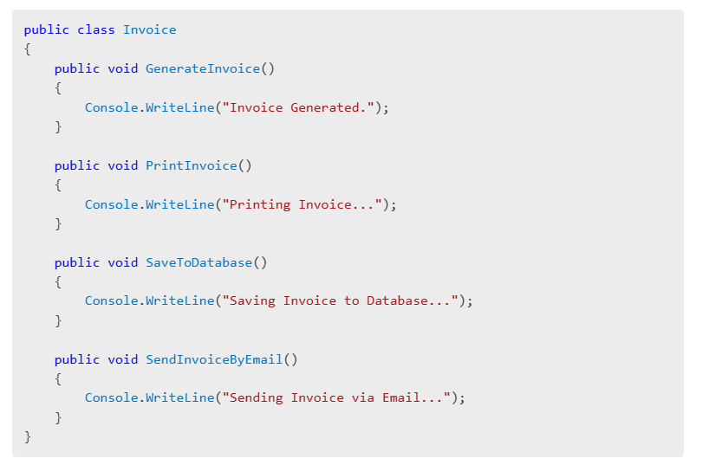

**Host**: "This class is responsible for **four different things**: generating, printing, saving, and emailing. If we need to change how invoices are printed, we might accidentally break how they’re generated or saved. That’s a maintenance nightmare."

**[Part 4: Refactoring with SRP]**

**Host**: "Now, let’s refactor this code to follow SRP. We’ll split the Invoice class into multiple classes, each handling a specific responsibility. Here’s the updated code."

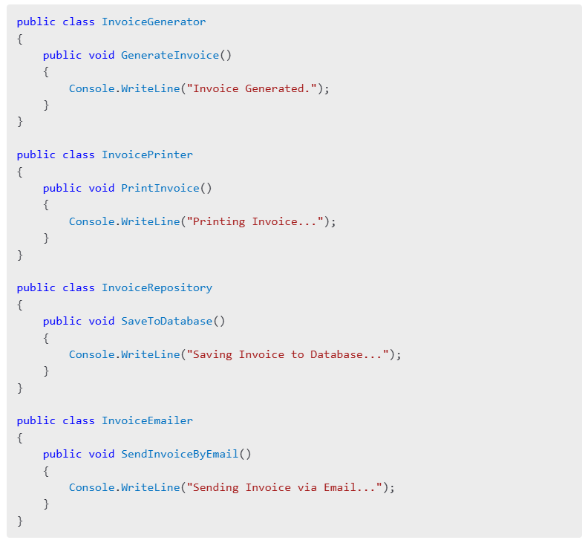**Host**: "Now, each class has a single responsibility. If we need to change the email functionality, we only update the InvoiceEmailer class. The other classes remain untouched. This makes the code more maintainable and less prone to bugs."

**[Part 5: Advantages and Disadvantages of SRP]**

**Host**: "Now that we’ve implemented SRP, let’s quickly go over its pros and cons."

**Advantages**:

* "Improved code maintainability."
* "Easier to test smaller, focused classes."
* "Encourages code reuse and scalability."

**Disadvantages**:

* "You might end up with more classes, which can feel overwhelming initially."
* "Increased complexity in managing dependencies."
* "For small projects, SRP can seem like overkill."

**[Part 6: Closing and Call-to-Action]**

**Host**: "To summarize, the Single Responsibility Principle helps you write clean, modular, and maintainable code by ensuring each class has a single job. By following SRP, you’ll avoid tightly coupled code and create a strong foundation for your applications."

**Host**: "What do you think about SRP? Have you faced challenges in breaking down responsibilities in your code? Share your thoughts in the comments below. And if you found this video helpful, please like, subscribe, and hit the notification bell so you don’t miss the next video in this SOLID principles series!"

**Host**: "Thank you for watching, and I’ll see you in the next video where we’ll discuss the **Open/Closed Principle**!"

[End with upbeat music and your channel logo.]

**[On-Screen Text Suggestions]**

1. "Key Takeaway: A class should have one reason to change."
2. "Breaking responsibilities = Better maintainability."
3. "Coming up next: Open/Closed Principle."

**Suggested B-Roll and Visuals**

1. **Animations**: Split-screen showing a class "splitting" into multiple focused classes.
2. **Text Popups**: Displaying advantages/disadvantages as the host explains them.
3. **Code Highlighting**: Highlight problem areas in the "violating SRP" example.

Let me know if you need further refinements or additional visuals for the script!